Part 1
_________________________________________________________________________________________
1. Pipeline Execution
The predictive pipeline implements a robust, multi-stage workflow designed to handle high-dimensional data with a bimodal target distribution. The execution flow is summarized below:
- Data Preparation & Feature Engineering: The script initializes by loading raw datasets and applying a custom engineering function that generates multiplicative interaction terms from the top six Mutual Information (MI) features.
- 5-Fold Cross-Validation (CV) Loop: To ensure statistical stability, the data is partitioned into five folds. Within each fold, the following sub-processes occur:
  - Leakage-Proof Scaling & PCA: A StandardScaler and PCA (26 components) are fitted strictly on the training fold and subsequently applied to the validation fold to prevent data leakage.
  - Feature Selection "Pilot": A preliminary CatBoost model identifies the most impactful features based on a 95.7th percentile importance threshold.
  - Final Model Training: A tuned CatBoost Regressor is trained using optimized hyperparameters based from Optuna runs (e.g., Depth: 8, Learning Rate: 0.04).
- Performance Aggregation: Fold-specific metrics (R2, RMSE, MAE) are calculated and averaged to provide a reliable estimate of generalization performance.
- Ensemble Inference: For the final evaluation, the script employs an ensemble approach, averaging predictions from all five fold-specific models to generate the final output.
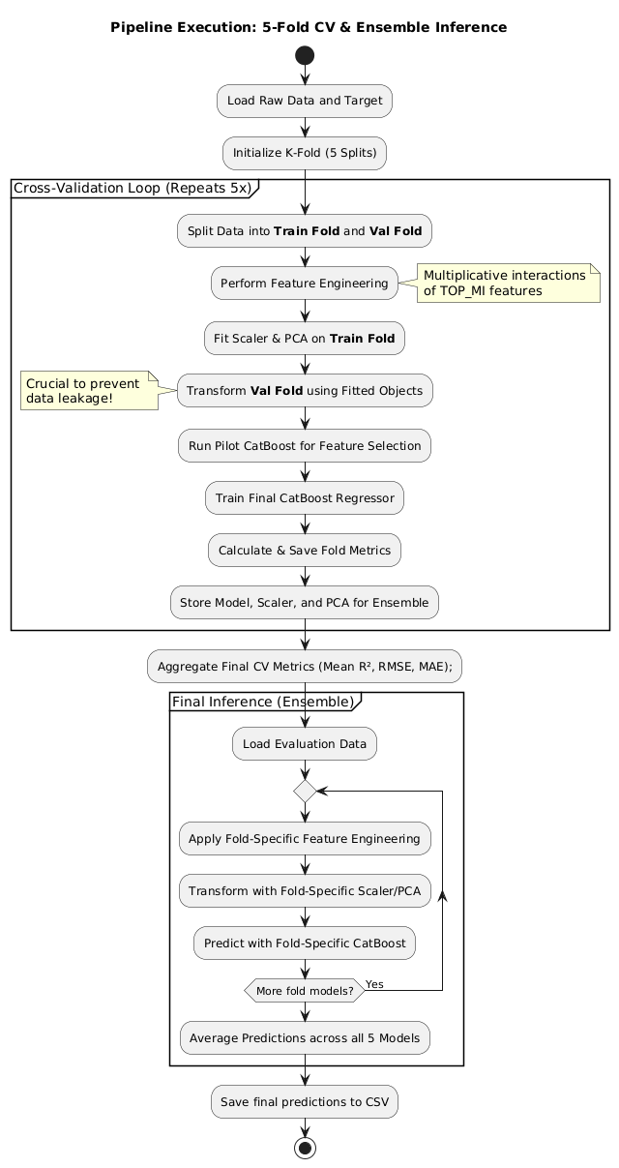

2. Key Observations
- Data Characteristics: The dataset consists of 273 numeric features in varying ranges, showing very weak linear correlations (maximum ~0.17) with the target and low individual Mutual Information scores.
The Bimodal Target
- Observation: target01 exhibits two distinct peaks (one sharp peak near 0.0 and a broader one near 0.45).
- Analysis: This suggested the data operates under two different "regimes." Standard regression (which targets the mean) might fail here without specific engineering.

3. Feature Engineering and Selection Strategy
- Mutual Information (MI): MI was used to identify non-linear relationships between the target01 and the features and top features were selected for the feature engineering.
- Interaction Terms: Created multiplicative features (e.g., f1 X f2) for the top 6 MI features. Multiplicative interactions capture complex non-linear dependencies and feature synergies that individual raw variables cannot represent in isolation.
- Different Interaction Tried: - The current Pipeline only use the multiplicative features, but multiple combinations were tried . like
  - Ratio features – (f1 / f2 + 1e-6)
  - Difference & absolute difference- (f1 - f2, abs (f1 - f2))
  - Sum & mean (f1 + f2, (f1 + f2) / 2)
  - Nonlinear transforms, Log transform/ Square / sqrt Etc
- It was found that only multiplicative features Contributed significantly to the pipline.
- Stats without Feature Engineering.
  - --- FINAL CV METRICS ---
  - TRAIN -> R2: 0.9594 | RMSE: 0.0365 | MAE: 0.0302
  - TEST -> R2: 0.7810 | RMSE: 0.0896 | MAE: 0.0749
  - 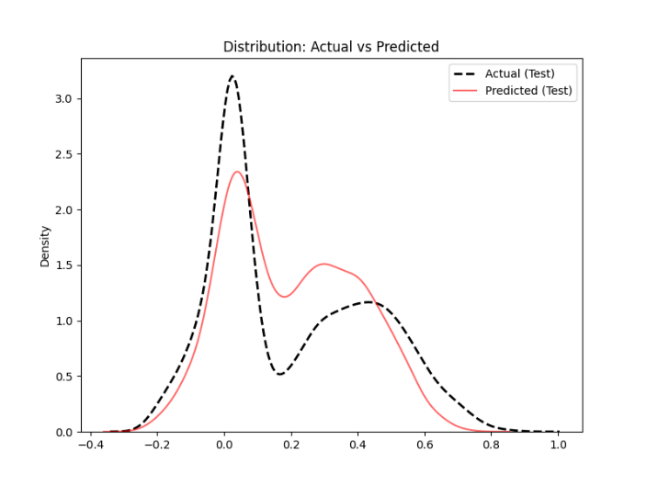
  - The significant drop in R2 (from 0.9594 on training to 0.7810 on testing) reveals substantial overfitting. Without the interaction terms and latent components provided by PCA, the model lacks the structural information needed to distinguish between the two target regimes.
  - It exhibits mode collapse, with predictions gravitating toward the mean of the bimodal distribution.
  - The narrow, high-density peak at 0.0 is significantly under-predicted, while the broader peak at 0.45 exhibits high variance and weak density separation.
- Recursive Feature Selection Pilot: To maintain model efficiency, a "Pilot" CatBoost model was used within each fold to calculate feature importance. Only features above the 95.7th percentile of importance were retained for the final training phase.
- Dimensionality Reduction: Before performing PCA, data was standardized using StandardScaler to prevent features with larger raw scales from dominating the principal components. PCA successfully compressed the signal into 26 latent components, which likely filtered out uninformative noise while retaining the core variance required to model the bimodal target.
  - Reduced the scaled feature space into 26 latent components. PCA captures the maximum variance in the data, likely filtering out noise while concentrating the signal into fewer dimensions. 26 latent components were chosen after Optuna tuning.
4. Modeling & Training Methodology
The development of the final predictive model followed an iterative, data-driven evolution. The objective was to systematically isolate the strongest learners and optimize their performance through multiple experimental phases.
a) Final Architecture: The final pipeline utilizes a CatBoost Regressor with a Bayesian bootstrap type and a depth of 8. This specific configuration was chosen because CatBoost’s internal handling of feature interactions naturally complemented the manually engineered multiplicative terms
4.1 Model Selection Evolution
The selection process began with a standard baseline and moved toward complex ensembling before settling on a high-precision single-model architecture.
- Initial Baseline (XGBoost): The project started with a standalone XGBoost regressor. However, the initial results were suboptimal, as the model struggled to capture the complex bimodal distribution with raw features alone.
- Averaged Ensemble (Optuna Run 1): To improve performance, a Stacked Ensemble was introduced consisting of XGBoost, LightGBM (LGBM), and CatBoost. By taking the simple mean of these three models, performance immediately improved to an R2 of 0.83.
- Weighted Blending (Optuna Runs 2-3): To refine the ensemble, model weights were introduced as hyperparameters. This allowed Optuna to determine the relative contribution of each algorithm. Analysis of these runs revealed that XGBoost's optimal weight was near zero (e.g., 0.0004 in Run 2), indicating it added noise rather than predictive value.
- CatBoost Dominance (Optuna Runs 4-6): XGBoost was removed, and the study focused on a CatBoost/LGBM duo. Even in this configuration, the weights heavily favored CatBoost (often > 0.89), while LGBM’s contribution dwindled.
- Final Configuration (Run 7): Based on the preceding evidence, the final model was streamlined into a high-performance CatBoost Regressor. This transition eliminated architectural redundancy while maximizing accuracy.
4.2 Hyperparameter Optimization (Optuna)
The final model parameters were derived through a series of Optuna studies, each consisting of 50 trials.
- Adaptive Range Tuning: A dynamic approach was taken where the search space for hyperparameters was adjusted between runs. If a parameter's best value hit the "floor" or "ceiling" of its defined range, the range was expanded or shifted in the subsequent run to ensure the true global optimum was captured.
- Regularization Focus: As the model became more complex, higher L2 leaf regularization and random strength parameters were explored to mitigate overfitting.
4.3 Iterative Performance Summary
The following table tracks the progression of the model's accuracy through the optimization cycles:
Run | Architecture | Key Change | Train Score (R2) | Test Score (R2)
1 | XGB + LGB + Cat | Simple Mean | 0.8300 | -
2 | XGB + LGB + Cat | Weighted Blend | 0.8734 | 0.8959
3 | XGB + LGB + Cat | Weight Search | 0.8823 | 0.9037
4 | LGB + Cat | Removed XGB | 0.8987 | 0.9057
6 | LGB + Cat | Range Expansion | 0.9441 | 0.9433
7 | CatBoost Only | Final Tuned | 0.9929 | 0.9568
4.4 Final Model Hyperparameters
The final optimized parameters used for the CatBoost regressor are as follows:
- Iterations: 1500
- Depth: 8
- Learning Rate: 0.0407
- L2 Leaf Reg: 5.5108
- Bagging Temperature: 0.7183
- Random Strength: 1.6049
- Feature Selection: Top 4.2% of features (fs_quantile: 0.9576)
- PCA Components: 26
This methodology ensured that every component of the final pipeline—from the feature count to the specific learning rate—was mathematically justified by its contribution to the final cross-validation score.

5. Results Performance Metrics & Stability
Diagnostic Statistics
- R² (Coefficient of Determination): 0.9568.
  - This indicates that 95.6% of the variance in the bimodal target is explained by the model.
- Cross-Validation Consistency: The 5-fold cross-validation demonstrated low variance across folds.
Fold | Train R2 | Test R2
Fold 1 | 0.9924 | 0.9530
Fold 2 | 0.9920 | 0.9494
Fold 3 | 0.9934 | 0.9532
Fold 4 | 0.9919 | 0.9508
Fold 5 | 0.9919 | 0.9524
- Stability Metric: Low standard deviation of 0.00162 (or approximately 0.16%) between folds (Test R2 ranged from 0.9494 to 0.9532), suggests limited sensitivity to data splits.
- Mean Performance: The final aggregate test metrics were.
Metric | Train (Average) | Test (Average)
R2 | 0.9923 | 0.9518
RMSE | 0.0207 | 0.0520
MAE | 0.0157 | 0.0391
- Mild Overfitting with Strong Generalization: There is a narrow gap of approximately 4% between the Train R2 (0.9923) and Test R2 (0.9518). While this indicates a slight degree of overfitting, the consistently high test performance suggests effective generalization under cross-validation. In a practical context, this minor trade-off is negligible because the model maintains such high predictive power on unseen data.
- Distribution Alignment: Visual inspection of the "Actual vs. Predicted" KDE plot between test data confirms that the model accurately captures the relative densities of both peaks (at ~0.0 and ~0.4) as well as the transition "valley" between them.
- 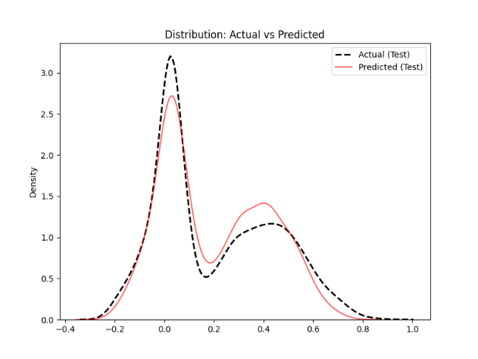
Inference & Generalization
- Fold-Ensemble Inference: To maximize generalization on the EVAL_7.csv dataset, the final predictions were generated using a 5-fold ensemble average.
- Pipeline Reproducibility: For each row in the evaluation set, the specific StandardScaler, PCA fit, and CatBoost model from each of the five training folds were applied sequentially. This ensures that the evaluation predictions are not biased by any single data split and benefit from the full variance captured during the cross-validation process
- Distribution on EVAL: The predicted distribution on the evaluation set is consistent in shape and modal structure with the training distribution.
- 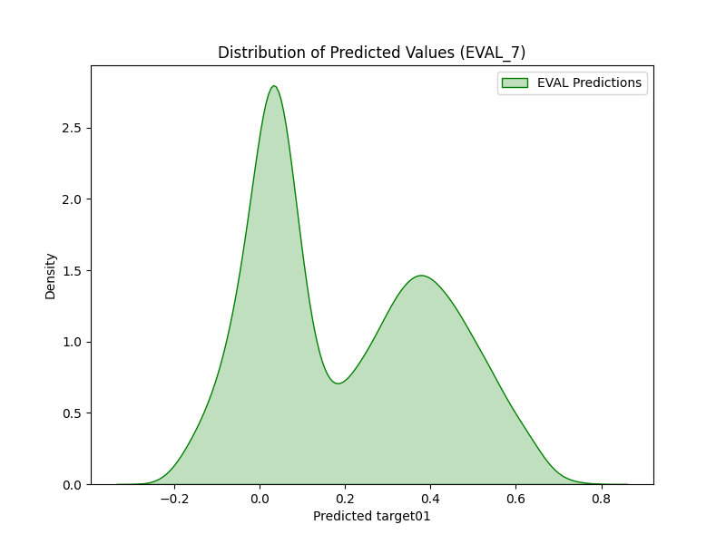
6. Conclusion
The predictive pipeline for Part 1 successfully addressed the challenges of a bimodal target distribution and high-dimensional noise¹. By evolving from a basic XGBoost baseline to a highly tuned CatBoost Regressor, the model achieved a robust Final Test R2 of 0.9518.
Key factors contributing to this performance include:
- Feature Synergy: Multiplicative interaction terms proved essential for distinguishing between target "regimes," increasing the Test R2 from 0.7810 to over 0.95.
- Dimensionality Integrity: The combination of 26 PCA latent components and a 95.7th percentile feature selection threshold effectively concentrated predictive signals while filtering out uninformative noise.
- High Stability: A low standard deviation of 0.16% across a 5-fold cross-validation confirms that the model generalizes reliably and is not sensitive to specific data splits.
Ultimately, the use of Fold-Ensemble Inference ensures that the final predictions on unseen evaluation data are balanced, unbiased, and statistically sound.

PART- 2
Analysis of Tree Config.
Depth | Degree | Train |  | Test
 |  | R Sq | RMSE | R Sq | RMSE
2 | 1 | 0.888 | 0.255 | 0.886 | 0.254
 | 2 | 0.961 | 0.152 | 0.956 | 0.157
3 | 1 | 0.974 | 0.122 | 0.966 | 0.138
 | 2 | 0.986 | 0.09 | 0.985 | 0.092
4 | 1 | 0.977 | 0.115 | 0.972 | 0.124
 | 2 | 0.989 | 0.077 | 0.986 | 0.087

Plot For Depth 3 and Degree 2
